|  |
| --- |
| Stock market trading screen |
| ADDB7311 PRACTICAL ASSIGNMENT  SUBMISSION |
| |  |  |  | | --- | --- | --- | | Onello Travis Tarjanne |  | ADDB7311 | |

ADDB7311 PRACTICAL ASSIGNMENT

Question 1

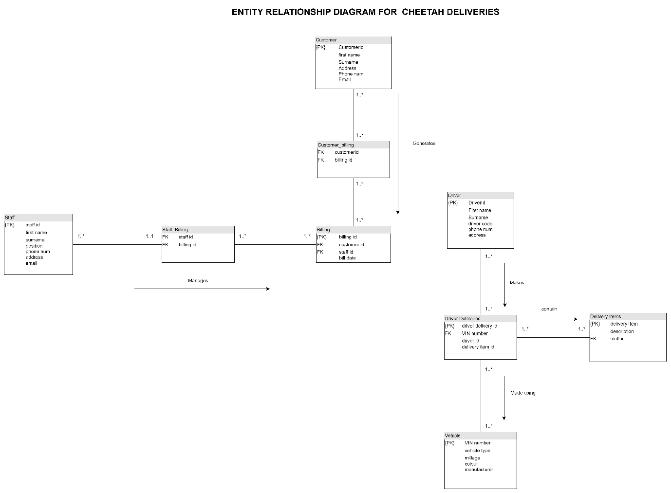

Question 2

Code:

-- customers table

CREATE TABLE customers (

Customer_id NUMBER,

first_name VARCHAR2(50),

Surname VARCHAR2(50),

address VARCHAR2(50),

Phone_num NUMBER,

email VARCHAR2(50)

);

SELECT * FROM customers

-- driver table

CREATE TABLE driver (

Driver_id NUMBER,

first_name VARCHAR2(50),

Surname VARCHAR2(50),

Driver_code VARCHAR2(50),

Phone_num NUMBER,

address VARCHAR2(50)

);

SELECT * FROM driver;

-- billing table

CREATE TABLE billing (

Bill_id NUMBER,

customer_id NUMBER,

staff_id NUMBER,

bill_date Date

);

SELECT * FROM billing;

-- delivery items table

CREATE TABLE delivery_items (

delivery_item NUMBER,

description VARCHAR2(50),

staff_id NUMBER

);

SELECT * FROM delivery_items;

-- deliverdeliveries

CREATE TABLE driverdeliveries (

driver_delivery_id NUMBER,

vin_number VARCHAR2(50),

driver_code NUMBER,

delivery NUMBER

);

SELECT * FROM driverdeliveries;

-- staff table

CREATE TABLE staff (

staff_id NUMBER,

first_name VARCHAR2(50),

Surname VARCHAR2(50),

position VARCHAR2(50),

Phone_num NUMBER,

address VARCHAR2(50),

email VARCHAR2(50)

);

SELECT * FROM staff;

-- vehicle table

CREATE TABLE vehicle (

vin_number VARCHAR2(50),

Surname VARCHAR2(50),

milage NUMBER,

address VARCHAR2(50),

email VARCHAR2(50)

);

SELECT * FROM vehicles;

Import process:

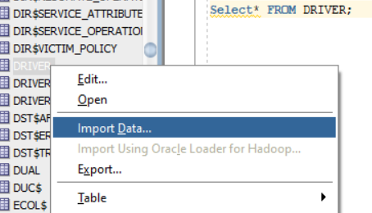

Figure 1 Importing option

Figure 2 Data import

Figure 3 Import method and selection

Tables:

Figure 4 Driver Table

Figure 5 Vehicle Table

Figure 6 Billing table

Figure 7 Customers Table

Figure 8 Staff table

Figure 9 driver deliveries table

Figure 10 Delivery items table

Question 3

3.1)Code:

BEGIN

-- Create user John

CREATE USER John IDENTIFIED BY Johnch2024;

-- Grant privilege to Jonh to select from any table in the database

GRANT SELECT ANY TABLE TO John;

-- Create user Hannah

CREATE USER Hannah IDENTIFIED BY Hannahch2024;

-- Grant privilege to Hannah to insert into any table in the database

GRANT INSERT ANY TABLE TO Hannah;

END;

/

3.2) The separation eliminates any confusion that may occur between the two users, they may have different roles, and the privileges are based on those roles.

Question 4

4.1)Code:

SELECT

d.Driver_code AS "CODE",

d.first_name || ' ' || d.Surname AS "Driver",

v.vin_number AS "VIN NUMBER",

v.milage AS "MILAGE"

FROM

driver d

JOIN

driverdeliveries dd ON d.Driver_code = dd.driver_code

JOIN

vehicles v ON dd.vin_number = v.vin_number

WHERE

v.milage < 80000;

4.2) A flat file table stores data in a single file or table, with no relationships between the entities, while a relational database has multiple tables representing different entities with primary keys and foreign keys. The relational database model would be ideal for cheetah deliveries and this model is highly scalable and enforces data security with the use of primary and foreign keys.

Question 5

5.1) Code:

DECLARE

v_staff_id staff.staff_id%TYPE;

v_first_name staff.first_name%TYPE;

v_surname staff.surname%TYPE;

v_billing_count NUMBER;

v_max_bills NUMBER := 0;

v_top_staff_id staff.staff_id%TYPE;

v_top_first_name staff.first_name%TYPE;

v_top_surname staff.surname%TYPE;

-- Cursor to select staff details

CURSOR c_staff IS

SELECT s.staff_id, s.first_name, s.surname

FROM staff s;

BEGIN

FOR r_staff IN c_staff LOOP

v_staff_id := r_staff.staff_id;

v_first_name := r_staff.first_name;

v_surname := r_staff.surname;

-- Calculate the number of deliveries processed by the staff member

SELECT COUNT(*)

INTO v_billing_count

FROM billing b

WHERE b.staff_id = v_staff_id;

IF v_billing_count > v_max_bills THEN

v_max_bills := v_billing_count;

v_top_staff_id := v_staff_id;

v_top_first_name := v_first_name;

v_top_surname := v_surname;

END IF;

END LOOP;

-- Output the report

DBMS_OUTPUT.PUT_LINE('----------------------------');

DBMS_OUTPUT.PUT_LINE('Staff ID: ' || v_top_staff_id);

DBMS_OUTPUT.PUT_LINE('First name: ' || v_top_first_name);

DBMS_OUTPUT.PUT_LINE('Surname: ' || v_top_surname);

DBMS_OUTPUT.PUT_LINE('Deliveries processed: ' || v_max_bills);

DBMS_OUTPUT.PUT_LINE('----------------------------');

END;

/

5.2) The 3 components of a SQL/PL block are the declaration block, the execution block and the exception block. In the declaration block all the variables are declared to hold the staff details displayed in the report. The execution block is where all the methods are executed and the logic of the project is, the count of the employees would be done there. Lastly is the exception block where all the error handling would be done.

5.3.1) A SQL view captures the query logic and simplifies the process of retrieving the necessary information, the simplicity eliminates the need for understanding the underlying SQL logic. SQL views can also be reused and be used to restrict access to specific data.

5.3.2)

-- creating the view

CREATE VIEW staff_delivery_report AS

-- selects the details for the

SELECT

s.staff_id,

s.first_name,

s.surname,

-- counts the items processed

COUNT(d.delivery_item) AS delivery_processed

FROM

staff s

LEFT JOIN

delivery_items d ON s.staff_id = d.staff_id

-- groups all the details for the report

GROUP BY

s.staff_id, s.first_name, s.surname;

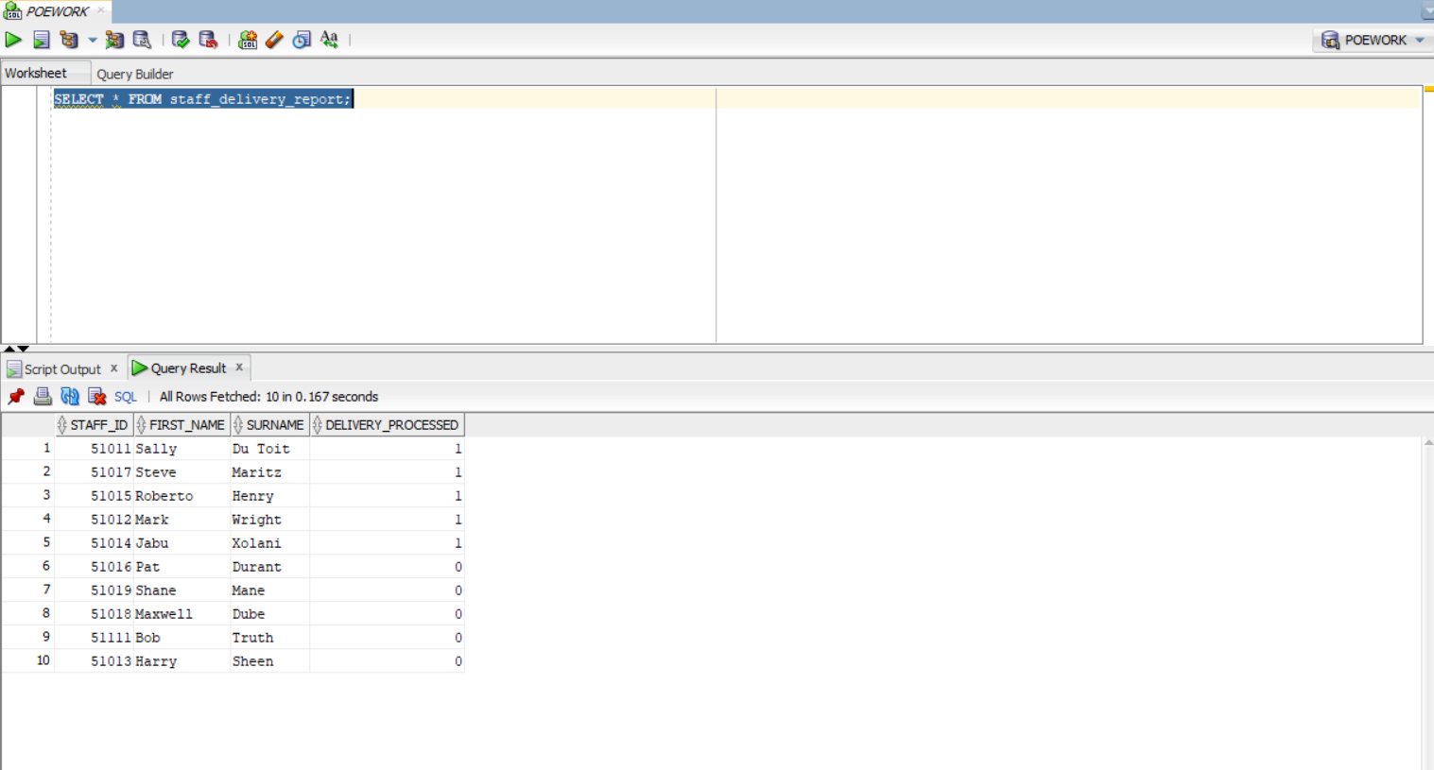

Figure 11 The view of all processed orders

Question 6

6.1) a) Implicit cursors are automatically generated by Oracle while an SQL statement is executed and used to process statements like INSERT, UPDATE, DELETE, in this scenario we would use implicit cursors to count the rows based on what is required.

b) Explicit cursors need to be defined explicitly by the user by providing a name and need to be created on a select statement. We would make use of them to fetch multiple rows as implicit can only fetch one at a time.

2.

DECLARE

total_rows NUMBER;

BEGIN

-- Implicit cursor

UPDATE driver

SET address = '26Carling Ave'

WHERE first_name = 'Wayne' AND surname = 'Smith';

IF SQL%NOTFOUND THEN

DBMS_OUTPUT.PUT_LINE('No drivers updated');

ELSE

total_rows := SQL%ROWCOUNT;

DBMS_OUTPUT.PUT_LINE(total_rows || ' driver(s) updated');

END IF;

END;

/

DECLARE

c_customer_id customers.customer_id%TYPE;

c_name customers.name%TYPE;

c_addr customers.address%TYPE;

CURSOR c_customers IS -- Cursor declaration for explicit cursor

SELECT customer_id, name, address FROM customers;

BEGIN

OPEN c_customers;

LOOP

FETCH c_customers INTO c_customer_id, c_name, c_addr;

EXIT WHEN c_customers%NOTFOUND;

DBMS_OUTPUT.PUT_LINE(c_customer_id || ' ' || c_name || ' ' || c_addr);

END LOOP;

CLOSE c_customers;

END;

/

6.2)A sequence would be used for the customer ID in the database, a customer sequence could be used.

Code:

-- Creating sequence

CREATE SEQUENCE customer_seq

START WITH 1

INCREMENT BY 1

NOCACHE

NOCYCLE;

-- Insert statements

INSERT INTO customers (customer_id, first_name, surname, address, phone_num, email)

VALUES (customer_seq.NEXTVAL, 'Autumn', 'James', '56 Hathaway St', 037373837, 'aj@inkedlink.com'),

(customer_seq.NEXTVAL, 'James', 'Taylor', 'Duke St', 0873457765, 'johndoe@example.com');

Figure 12 Output for sequence after inserting 3 values

# REFERENCES

PL/SQL cursor - javatpoint (2024) www.javatpoint.com. Available at: https://www.javatpoint.com/pl-sql-cursor (Accessed: 04 September 2024).

GeeksforGeeks (2022) Difference between implicit and explicit cursors, GeeksforGeeks. Available at: https://www.geeksforgeeks.org/difference-between-implicit-and-explicit-cursors/ (Accessed: 04 September 2024).

PL/SQL cursor - javatpoint (2023) www.javatpoint.com. Available at: https://www.javatpoint.com/pl-sql-cursor (Accessed: 04 September 2024).

Gaetjen, S., Knox, D. and Maroulis, W. (2015) Oracle Database 12C security, O’Reilly Online Learning. Available at: https://www.oreilly.com/library/view/oracledatabase-12c/9780071824286/ (Accessed: 27 August 2024).

IIE(2024) ADVANCED DATABASES MODULE MANUAL Available at: <https://advtechonline.sharepoint.com/sites/TertiaryStudents/IIE%20Student%20Materials/Forms/Default%20View.aspx?id=%2Fsites%2FTertiaryStudents%2FIIE%20Student%20Materials%2FNew%20Student%20Materials%20CAT%2FADDB7311%2F2024%2FADDB7311MM%2Epdf&viewid=db15e059%2D4f93%2D487f%2Dabda%2De538b821c7b8&parent=%2Fsites%2FTertiaryStudents%2FIIE%20Student%20Materials%2FNew%20Student%20Materials%20CAT%2FADDB7311%2F2024>